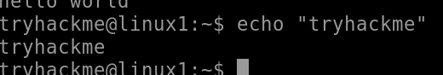

https://miro.medium.com/v2/resize:fit:332/1*GMLI-g0J7hCfA6FvbWgFMw.png

https://miro.medium.com/v2/resize:fit:626/1*kX2L07c5OPc-H-Zki8tg3Q.png

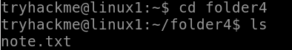

https://miro.medium.com/v2/resize:fit:517/1*3pbCZPJu9k9L_C-xj9ULVA.png

https://miro.medium.com/v2/resize:fit:397/1*JdsA2MMzB_ueEx3kbxkjZQ.png

https://miro.medium.com/v2/resize:fit:700/1*E9ZSVdtmVXtooBQAC9d9wQ.png

